Audit Update of the Economic Action Plan Funding for
2010-2011

June 16, 2011

Key Dates

Opening conference date (launch memo) | September 2010
Closing conference date (exit debrief) | March 2011
Audit report sent to management | May 2011
Management response received date | June 2011
Penultimate draft report approved by CAE | June 2011
Audit committee recommended | June 2011
Deputy Minister approval date | December 2011

List of Acronyms

EAP | Canada’s Economic Action Plan
EC | Environment Canada
MFS | Managers, Financial Services
MVR | Management Variance Report
PWGSC | Public Works and Government Services Canada
TBS | Treasury Board Secretariat

Prepared by the Audit and Evaluation Team

Acknowledgments

The audit team responsible for this project was led by Sophie Boisvert, Audit Manager and included Graça Rebelo Cabeceiras, under the direction of Jean Leclerc, Director. The audit team would like to thank those individuals who contributed to this project and, particularly, employees and managers involved in managing the funding received via Canada’s Economic Action Plan, who provided insights and comments as part of this audit.

Table of Contents

EXECUTIVE SUMMARY i
1 INTRODUCTION 3
1.1 Background 3
1.2 Preliminary Risk Assessment 4
1.3 Objective and Scope 4
1.4 Methodology 5
2 FINDINGS AND RECOMMENDATIONS 5
2.1 EAP Controls on Data Reliability and Reporting Compliance 5
2.2 Spending of EAP funding 7
3 CONCLUSION 9
Annex 1 Audit Criteria 10
Annex 2 List of Interviewees 11
Annex 3 EAP Monthly Financial Reporting Process 12
Annex 4 List of Background Information and Supporting Documentation 13

EXECUTIVE SUMMARY

On January 27, 2009, the Government of Canada announced Canada’s Economic Action Plan (EAP), which injected $60 billion into the Canadian economy over a two-year period, to jump-start growth and sustain economic recovery. In the 2009-2010 fiscal year, the EAP provided Environment Canada (EC) with a budget of $43.7 million over two fiscal years for five programs.

Departments that received EAP stimulus funding had to ensure that the money was spent within the expected timeframe, for the intended purpose, and with due diligence. Given the high visibility of this initiative, and the quick turn around for the disbursements, two audits of the EAP funding were included in the Department’s Three-Year Risk-Based Audit and Evaluation Plan 2009–2012, as approved by the Deputy Minister. The purpose of these audits was to ensure due diligence and effective risk management of the expenditure of the stimulus funding over the two years.

The first audit, the Audit of the Management Funding Receive through Canada’s Economic Action Plan” conducted in 2009-2010, concluded that the departmental monthly reporting had allowed the Department to monitor funds spent and progress made on the EAP programs. In addition, the testing of transactions against Treasury Board Secretariat Accounts Verification Directive did not uncover major control deficiencies and therefore no recommendation was required at that time.

Objective and Scope

The objective of this audit update was to determine if the funds received in 2010-2011 as part of EAP stimulus funding were flowing expeditiously and whether control over monthly reporting was adequate and complied with Treasury Board requirements. The scope of the audit included the economic stimulus expenditure activities managed by EC during fiscal year 2010–2011, and served to build upon and complement the work done under the initial 2009-2010 audit. Of the five EC programs receiving EAP funding, three received funding during 2010-2011: Modernizing Federal Laboratories, Accelerated Federal Contaminated Sites Action Plan, and Maintenance or Upgrading of Existing Arctic Research Facilities.

Statement of Assurance

This audit was conducted in accordance with the International Standards for the Professional Practice of Internal Auditing and the Treasury Board Policy on Internal Audit. In our professional judgement, sufficient and appropriate audit procedures have been conducted and evidence gathered to support the accuracy of the conclusions contained in this report. The conclusions were based on the facts as they existed at the time of the audit (Period 8 – November 2010) and updated information (Period 12 - March 2011) received before the issuance of this report.

Summary of Findings and Conclusions

Based on the results of the audit work, which consisted of a documentation review and analysis, interviews, and examinations, the controls in place to report on the EAP funding are adequate, with the exception of one potential issue specific to the treatment of commitments. The result of interviews and documentation review indicated that the recording and reporting on commitments are not standardized for the purposes of EAP
reporting.

Recommendation

The Assistant Deputy Minister, Finance and Corporate Branch and Chief Financial Officer should ensure that commitments are recorded, monitored and discharged in a standardized fashion and in accordance with the Directive on Expenditure Initiation and Commitment Control.

Management Response

Management agrees and a detailed action plan to address the audit recommendation has been developed.

INTRODUCTION
This audit was included in the 2010-2011 to 2012- 2013 Risk-Based Audit and Evaluation Plan, which was approved by the Deputy Minister in early spring 2010.

Background

On January 27, 2009, the Government of Canada announced Canada’s Economic Action Plan (EAP), which injected $60 billion into the Canadian economy over a two-year period, to jump-start growth and sustain economic recovery. In the 2009-2010 fiscal year, EAP provided Environment Canada (EC) with a total budget of $43.7 million over two fiscal years for five programs, as represented in Table 1.

Table 1 – Environment Canada Programs Financed through EAP Funding

Programs | Funding  Timeline (years) | Total Budget  ($millions) | Budget for  2009-2010  ($millions) | Budget for  2010-2011  ($millions)
Modernizing Federal Laboratories | 2 | 13.7 | 6.5 | 7.2
Accelerated Federal Contaminated Sites Action Plan | 2 | 12.7 | 2.9 | 9.8
Canadian Environmental Sustainability Indicators | 1 | 6.2 | 6.2 | 0
Promoting Energy Development in the North - Mackenzie Gas | 1 | 10.4 | 10.4 | 0
Maintenance or Upgrading of Existing Arctic Research Facilities (note 1) | 2 | 0.7 | 0.3 | 0.4
Total: |  | 43.7 | 26.3 | 17.4

Note 1: In 2009-2010, the maintenance and upgrading of existing Arctic Research Facilities was with Indian and Northern Affairs Canada. In 2010-2011, the lead was transferred to Environment Canada.

Departments that received stimulus funding had to ensure that the money was spent within the expected time frame, for the intended purpose, and with due diligence. Given the high visibility of this initiative, and the quick turnaround for the disbursements, two audits of the EAP funding were conducted: a first one in 2009-2010 and this one in 2010-2011.

A first audit, the Audit of the Management of Funding Received through Canada’s Economic Action Plan” conducted in 2009-2010 concluded that the departmental monthly reporting had allowed the Department to monitor funds spent and progress made on the EAP programs. It was noted that increased dealings with third party stakeholders, such as Public Works and Government Services Canada, presented challenges on the ability of program managers to spend allocated funds within the given timeframe. However, measures had been taken to ensure the delivery of the programs. All programs that received funding through EAP were completed on time and within budget. Of those programs, two were sunsetting in 2009-2010. The increased frequency of reporting helped identify some coding errors early on in the process which resulted in
timely corrections to the data recorded in the Department's financial system. Based on the results of the 2009-2010 audit of the EAP, no major control deficiencies were noted and no recommendations were required.

Preliminary Risk Assessment

Considering that Environment Canada received only a small portion of the total EAP funding (less that 1% of total government-wide EAP funding for 2009-2010 and 2010-2011), the department is probably less at risk than other organizations. Furthermore, most of the EAP funding received for the second year was injected into existing programs, thus avoiding risks associated with the creation of new programs. New programs require defining the rationale, objectives, roles and responsibilities, aligning with policies, processes and procedures, and establishing controls for monitoring and reporting.

During the planning phase of this audit, interviews with senior management and managers responsible for delivering the department’s EAP programs identified the following as the Department’s main risks:

- Risks associated with controls and processes in place to manage the EAP funds, such as:
- potential errors arising from accelerating the contracting requests through existing processes; and
- accuracy of financial information, including commitments
- Risks associated with the ability to spend the funding within the allocated timeframe.

Objective and Scope

This second audit looks at the second year (2010-2011) funding received through the Economic Action Plan consisting of $17.4 million for three programs: two programs continued from the first year, and the funding for one program (Maintenance or Upgrading of Existing Arctic Research Facilities) was transferred to EC from Indian Affairs and Northern Development (now Aboriginal Affairs and Northern Development Canada).

The objectives of this audit update were to determine if the funds received in 2010-2011 as part of EAP stimulus funding were flowing expeditiously and whether control over the mandatory monthly EAP reporting was adequate and complied with Treasury Board Secretariat (TBS) requirements.

The scope of the audit included the economic stimulus expenditure activities managed by EC during fiscal year 2010–2011, and served to build upon and complement the work done under the previous 2009-2010 audit.

EAP funding for 2010-2011 amounts to $17.4 million. The time period covered by the audit included all monthly reporting activities up to the end of November 2010 and updated information (Period 12 - March 2011) received before the issuance of this report. Detailed audit criteria are provided in Annex 1.

Methodology

The audit update methodology included:

- A review and analysis of documentation such as monthly financial reports and briefings related to EC’s EAP funding, submitted to TBS and the Deputy Minister.
- An analysis of current expenditures and commitment patterns against prior year.
- A review of the controls relating to the EAP financial reporting process at EC.
- Interviews with management to confirm any changes to the control process on the management of the EAP funding and to ascertain current risks for programs (refer to Annex 2 – List of Interviewees).
- Examination of control procedures for the sign-off of monthly reports to TBS.

The audit update looked into whether the Department was compliant with Treasury Board requirements specific to monthly reporting of EAP funding. In addition, based on the relatively low value of 2010- 2011 EAP funding and the positive conclusion of the 2009-2010 audit, the present audit is considered as an update only and detailed testing was not considered necessary. Accordingly, this audit did not include a review of issues regarding invoice approval and transaction initiation, certification of work performance, payment legitimacy, payment verification and contracting.

FINDINGS AND RECOMMENDATIONS

Although Modernizing Federal Laboratories was a new initiative in 2009, the management of federal laboratories as well as the management of the Accelerated Federal Contaminated Site Action Plan are programs that have been in place for nearly 30 years. Therefore managers are familiar with these activities and how they function. Managers possess a thorough and strong system of monitoring allowing them to produce detailed financial reports at any time.

With respect to Maintenance or Upgrading of Existing Arctic Research Facilities, both the Program manager and the manager of financial services indicated that the relatively small budget ($448,000 for 2010-2011 and a total of $749,000 over two years) facilitated data tracking and coding, reducing the risks of reporting errors specific to the EAP funding.

EAP Controls on Data Reliability and Reporting Compliance

TBS instructions for EAP reporting required Departments to provide monthly reports identifying the budget for the fiscal year for each EAP program, the portion of the funding that was committed, and the actual expenditures for that specific month. The financial
reporting process in place for fiscal year 2010-2011 was the same as the one used for fiscal year 2009-2010. Annex 3 outlines the process steps.

This financial reporting process was developed by key players, including Corporate Management, the managers of EC’s Financial Services Division, and departmental program managers. The idea was to foster proactive engagement between all key players in order to enhance the adequacy, integrity and timeliness of the financial information in order to meet the TBS short reporting turnaround time for the EAP initiatives.

The controls in place are numerous and include reports and briefings to the Deputy Minister, joint consultation, unique authority code, site visits by program managers, project tracker and status reports, and an exhaustive validation and reconciliation process as described in Annex 3. The Department uses specific EAP authority and project codes to track and manage expenditures related to EAP funding. This control ensures that the funds are disbursed for EAP initiatives and not for regular activities of the programs.

The documentation review indicated that managers are required to report their financial information on a monthly basis, so that progress reports can be validated and approved at the appropriate levels. As required, these reports are rolled up and provided to TBS on a monthly basis. In addition, the Deputy Minister is provided with detailed monthly reporting that outlines progress, trends, variances, explanations, risks and risk mitigation strategies.

The audit team examined the sign-off process for the reporting in Periods 5 and 6 of fiscal year 2010-2011 (August and September 2010). Evidence indicates that all sign-offs were carried out according to the planned process, either on the financial reporting template or in some cases via emails. The documentation review also revealed that an error in the actual expenditures reported to TBS during Period 2 (May 2010) was uncovered by the Finance and Corporate Branch and corrected during Period 3 (June 2010).

As for information on job creation, EC is required to indicate the number of employees hired by the Department for the EAP. This information is included in the monthly reporting to TBS. The Department is not required to report on overall job impact numbers.

Based on the results of the documentation review and analysis, the audit team concluded that the controls in place to report on the EAP funding are adequate and comply with TBS requirements. A review of the monthly reports data compilation and reconciliation as well as the sign-off process indicated that the financial information is reliable.

Recommendation

No recommendation is required.

Spending of EAP funding

During the planning phase of this audit, the ability for the program managers to spend the allocated funds within the fiscal year was one of the concerns expressed by senior management.

At the end of the audit fieldwork (Period 8 – November 2010), 13% of the funding was not yet spent or committed, which represented approximately $2.3 million. De-commitments in Modernizing Federal Laboratories were expected, and an additional $86,000, comprising $66,000 for the Secretariat of the Accelerated Federal Contaminated Sites Action Plan and $20,000 for the Arctic Research Investment Fund, was at risk of not being spent at year-end. Based on this analysis and the documentation review, although 13% of the funding was not yet spent or committed, program managers were still forecasting to spend the majority of their budget by end of fiscal year.

Updated information as of March 31, 2011 (Period 12), presented below indicates that, overall, the three initiatives spent 88% of the total funding received through the EAP for fiscal year 2010-2011, resulting in an anticipated $1.9 million in lapsed funding (12% of the total funding). The anticipated lapse at year-end is significantly more than managers forecasted at period 8 (November 2010).

Although federal departments are normally permitted to carry-forward lapsed funding up to a maximum of 5% of their operating vote and 20% of the capital vote, lapsed funding within EAP is not eligible for the carry-forward to the next fiscal year.

Program  (DRAFT as of March 31, 2011  Period 12) | Budget for 2010-11 | Budget Funding Committed | Actual Expenditures | Balance Remaining
Modernizing Federal Laboratories | $7,227,000 | $2,627,340 | $3,744,719 | $854,941
Federal Contaminated Sites Action Plan | $9,778,492 | $1,360,993 | $7,358,516 | $1,058,983
Maintenance or upgrading of existing Arctic research facilities | $448,000 | $13,353 | $399,435 | $35,212
Total | $17,453,492 | $4,001,686 | $11,502,670 | $1,949,136
These figures are those that were available at the time of the audit. Since then, year-end financial information has been made available and the department reported in its 2010-2011 Departmental Performance Report that only $0.7M has not been spent of the total EAP budget for 2010-2011.

Modernizing Federal Laboratories

The analysis of expenditures and commitments as at Period 8 (November 2010) indicated that these totaled 97% of the funding for 2010-2011, compared to 75% for the same period in 2009-2010. The expenditures (excluding commitments) totaled 16% of the budget funding in 2010-11, compared to 5% for the same period in 2009-2010.

An analysis of draft data provided to TBS for Period 12 (March 2011) indicated that this program had spent only 88% of total funding for 2010-2011, representing an expected lapse of approximately $855,000 at year-end.

Accelerated Federal Contaminated Sites Action Plan

Our analysis as of Period 8 (November 2010) indicated that managers were well on their way to spending their entire budget; 81% of the funding was already expensed or committed. For the same period last year, the program had already expensed or committed 97% of the funding. This variance could indicate some slippage. However, when analyzing expenditures only, the program was further ahead this year ( 33%) compared to the same period last year (4%).

The information provided to TBS for Period 12 (March 2011) indicated that this program had spent only 89% of total budget funding for 2010-2011, representing an expected lapse of approximately $1.05 million. For this program, there was also uncertainty in the estimated costs of planned contracts, and potential delays in putting contracts into place.

Arctic Research Investment Funds

In 2009-2010, the maintenance or upgrading of existing Arctic Research Facilities was reported by Indian Affairs and Northern Development (now Aboriginal Affairs and Northern Development Canada). In 2010-2011, the lead was transferred to EC and is therefore included in this audit.

The draft data provided to TBS for Period 12 (March 2011) indicated that the program had spent 92% of total budget funding for 2010-2011 representing a lapse of only $35,000.

The result of our examination also indicates that the recording and reporting of soft commitments may not have been standardized for the purpose of EAP reporting. The TBS directive on Expenditure Initiation and Commitment Control requires that the recording and reporting on commitments be standardized throughout the organization.
The Finance and Corporate Branch provided managers of the Financial Services Division with flexibility in the treatment of commitments for EAP funding, based on their knowledge of the program but, although, the intent of this was to improve reporting to TBS, it may have affected the consistency of commitments reported.

Recommendation

The Assistant Deputy Minister, Finance and Corporate Branch and Chief Financial Officer should develop guidelines regarding the treatment of soft commitments to ensure that they are recorded, monitored and discharged in a standardized fashion and in accordance with the Directive on Expenditure Initiation and Commitment Control.

Management Response

Management agrees and a detailed action plan to address the audit recommendation has been developed.

CONCLUSION

Based on the results of the audit work conducted in fiscal year 2009-2010 and 2010-2011, the controls in place to report on the EAP funding were adequate, with the exception of an issue specific to the treatment of commitments.

In addition, results of Period 8 (November 2010) analysis and documentation review indicated that program managers were forecasting to spend essentially the majority of their budget. Updated information indicated that the three initiatives had spent 88% of the total funding received through the EAP by March 31, 2011, representing an expected lapse of $1.9 million. An analysis of the spending patterns for each of the initiative indicates that difficulties appear to have been encountered with the treatment of commitments.

A recommendation is directed to the Assistant Deputy Minister, Finance and Corporate Branch, and Chief Financial Officer to review the treatment of commitments.

Annex 1
Audit Criteria
Control Objective: | Criteria
EAP funds are spent within the allocated timeframe | 1. EAP funds are spent in a timely manner and within the fiscal year.
Monthly reporting is adequate and compliant to TB requirements | - Funds are tracked and reported accurately (Adequate financial systems and processes are used for monitoring and reporting)  - Appropriate sign-offs (reconciled and validated) are obtained  - Reports are submitted on time.

Annex 2
List of Interviewees

# | Role in EAP | Title and Sector
1 | Reporting to the Deputy Minister and TBS | Executive Director  Clean Air Agenda - Results Management Secretariat  Corporate Management  Finance and Corporate Branch
2 | Monthly Report to TBS signing authority for:  - Modernizing Federal Laboratories  - Federal Contaminated Sites Action Plan | Director of Property Management  Assets, Contracting and Environmental Management  Finance and Corporate Branch
3 | Final Validation of the reports to the Deputy Minister and TBS | Head, External Financial Planning & Reporting  Finance Directorate
4 | Finance process and Soft Commitments | Manager ,Financial Services: Modernizing Federal Laboratories; Contaminated Sites (Program)
5 | Finance process and Soft Commitments | Manager, Financial Services: Arctic Research Investment Funds

Annex 3 EAP Monthly Financial Reporting Process

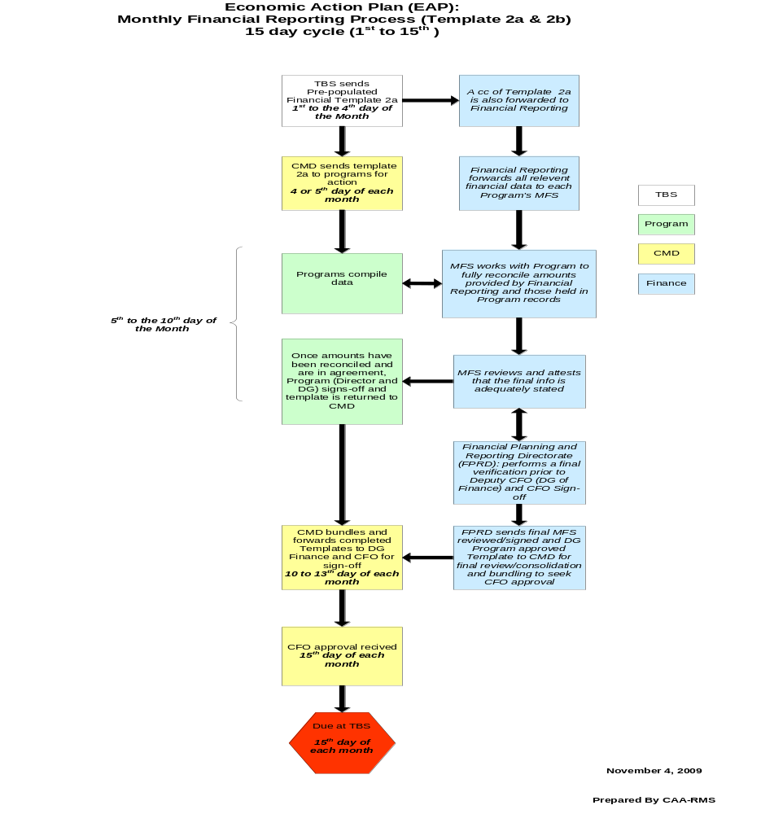

Annex 4
List of Background Information and Supporting Documentation

- Audit of the Management of Funding Received through Canada’s Economic Action Plan (EAP) – Part I, and related working papers, Audit and Evaluation Branch, EC, June 22, 2010.
- Monthly Financial Reporting Process, Templates 2a and 2b, 15-day cycle. Clean Air Agenda - Results Management Secretariat, Finance and Corporate Branch, EC, November 4, 2009.
- Reporting on the Economic Action Plan Funding Provided to Programs within Environment Canada, Meeting Summary. This meeting involved all key program, finance and corporate representatives, to discuss improvements in communications and methodology for monthly financial reporting, EC, October 22, 2009.
- Template 2a& 2b, Environment Canada 2010-11: Authorities and nationwide spending on EAP initiatives, fiscal year 2009-2010 and periods 1 to 8 fiscal year 2010-2011, Clean Air Agenda - Results Management Secretariat, Finance and Corporate Branch, EC.
- Economic Action Plan Overview, Status Report as of August 31, 2010 (periods 5-8) to the Deputy Minister, Clean Air Agenda - Results Management Secretariat, Finance and Corporate Branch, EC.
- Templates 2 for EAP financial reporting, for TBS purposes, For DM internal management report, fiscal year 2009-2010; and periods 1 to 8 fiscal year 2010-2011, Clean Air Agenda - Results Management Secretariat, Finance and Corporate Branch, EC.
- Financials to date: fiscal year 2009-2010 only. Totals provided from monthly reports to TBS as of April 2009, based on Template 2A information; Total budget amounts for 2009-2010 aligned with TB approvals as of early June 2009; EC.
- Economic Action Plan Reporting, Item #5, Notes & Action Items (for finance and Corporate Branch internal use). Weekly finance teleconference, Finance and Corporate Branch, EC, September 7, 2010.
- Budget, Commitment and Expenditure Summary Report, Period 6 (September 2010), fiscal year 2010-2011, from the EC Financial System and from the Salary Management System (SMS), Financial Planning and Reporting Division, Finance and Corporate Branch, EC.
- Various emails between managers of the Financial Services Division, the Financial Planning and Reporting Division, Financial Systems Operations / Integrated Enterprise Services, program managers and Clean Air Agenda - Results Management Secretariat, EC, summer and fall 2010.
- Evidence for all sign offs for periods 1 to 6 fiscal year 2010-2011,Clean Air Agenda - Results Management Secretariat, Finance and Corporate Branch, EC.
- Canada's Economic Action Plan: A Seventh Report To Canadians. http://www.actionplan.gc.ca/eng/feature.asp?pageId=223
- Treatment of EAP Funding in the 2010-11 to 2011-12 Operational Budget Carry Forward (OBCF) & Capital Budget Carry Forward (CBCF) Calculations, Tuesday, November 09, 2010.

De-commitment: freeing funds that were previously set aside for a specific financial obligation that has changed or is no longer valid
The budget comprises $5M in the capital vote ( Modernizing Federal Laboratories), with the remaining in the operating vote

